Step 1: Implementing Resource Monitoring via AWS CloudWatch

Technical Overview
In this phase, I configured comprehensive monitoring for the EC2 instance to ensure operational visibility and security baseline auditing. By utilizing Amazon CloudWatch, I gained real-time insights into system performance and resource consumption.

Key Metrics Monitored:
- CPU Utilization: Tracks the processing load on the instance. Significant spikes may indicate a potential Denial of Service (DoS) attempt or an inefficient process that needs optimization.
- Memory Utilization (via CloudWatch Agent): Unlike CPU, memory metrics are not collected by default at the hypervisor level. I deployed the CloudWatch Agent on the instance to push custom OS-level metrics, providing a deeper view of the system's health.
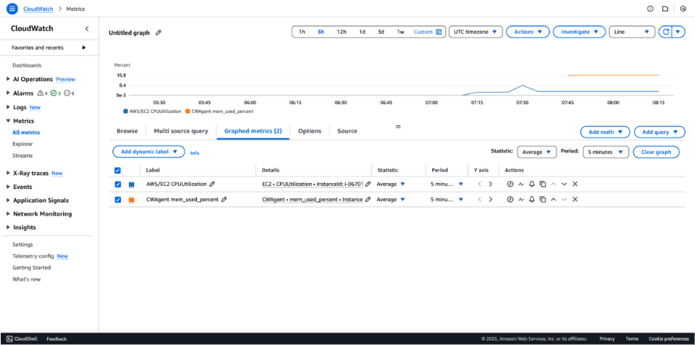

Step 2: Proactive Threat Detection with CloudWatch Alarms

Technical Overview
While monitoring provides visibility (as shown in Step 1), effective cloud operations require proactive detection. In this step, I transitioned from passive monitoring to automated alerting by configuring CloudWatch Alarms based on critical performance and security baselines.

Security Baselines and Alerts Configured:
I defined and implemented precise alert conditions to detect anomalies that might indicate operational failure or a security incident. The alarms shown in the screenshot serve distinct purposes:
- High CPU Utilization Alarm:
  - Threshold: > 80% sustained for 5 consecutive minutes.
  - Rationale: Detects sustained high-load situations. Beyond performance bottlenecks, this is a critical early warning for potential resource-exhaustion attacks, such as distributed denial-of-service (DDoS) attempts or unauthorized cryptocurrency mining (cryptojacking) by an attacker who has compromised the instance.
- High Memory Utilization Alarm:
  - Threshold: > 75% sustained for 5 consecutive minutes.
  - Rationale: Leverages the custom metric from the CloudWatch Agent. Sustained high memory usage is a critical indicator of a memory leak or a sophisticated buffer overflow attempt, allowing security teams to intervene before a system crash occurs.

Integrated Notification Layer:
These alarms are linked to an Amazon SNS (Simple Notification Service) topic. When an alarm state is triggered, an automated email notification is dispatched to the operational team, ensuring immediate visibility into the incident.
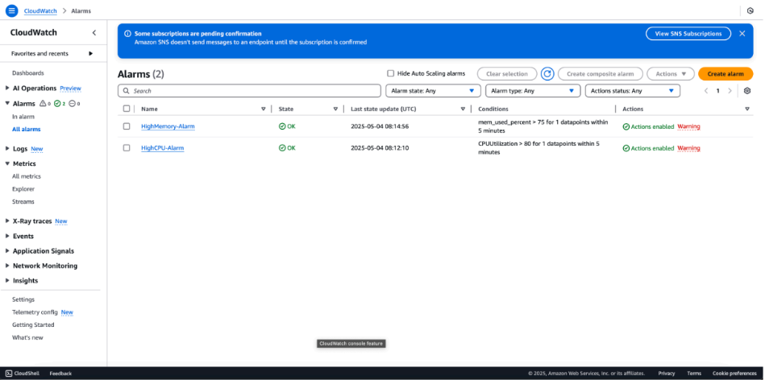
Step 3: Orchestrating Real-Time Incident Notifications via Amazon SNS

Technical Overview
To ensure immediate awareness of potential security or performance issues, I integrated Amazon Simple Notification Service (SNS) with the CloudWatch Alarms configured in the previous step. This creates an automated notification pipeline that bridges the gap between detection and manual or automated intervention.

Implementation Details:
- SNS Topic Creation: I created a dedicated SNS topic (standard type) to serve as a centralized hub for all resource-related alerts.
- Protocol Configuration: Configured an Email Protocol subscription to ensure that critical alerts are pushed directly to the security analyst’s inbox.
- Subscription Validation: As seen in the screenshots, the subscription status is "Confirmed." This is a critical step in AWS to prevent "dead-letter" notifications and ensure that the communication channel is verified and active.
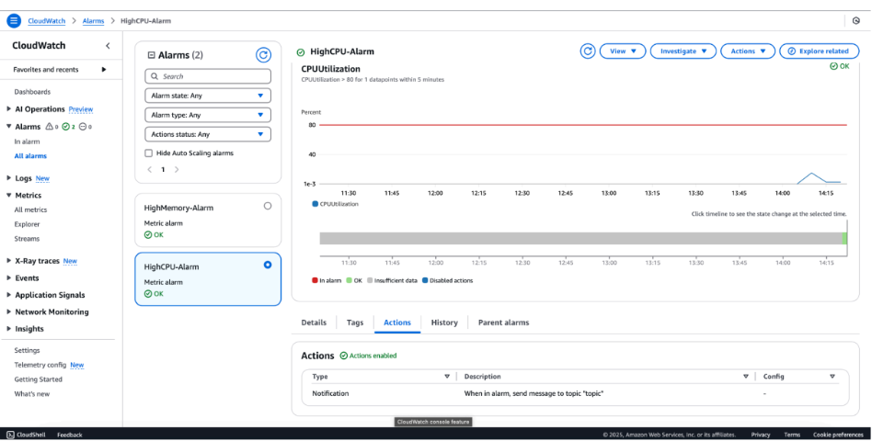
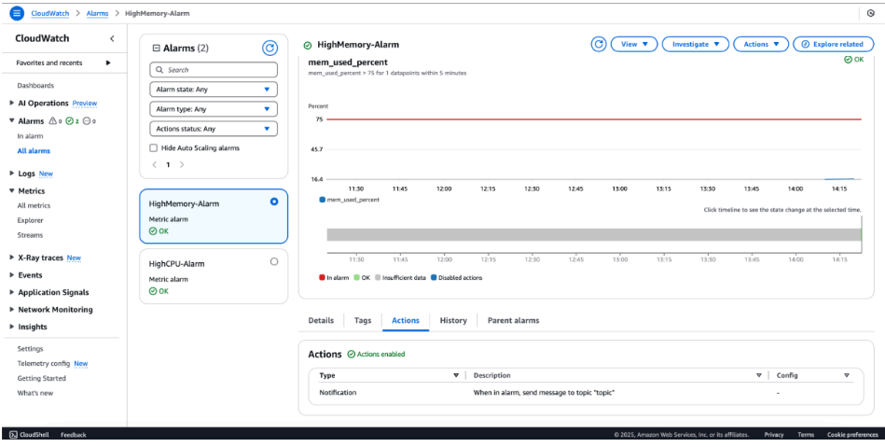
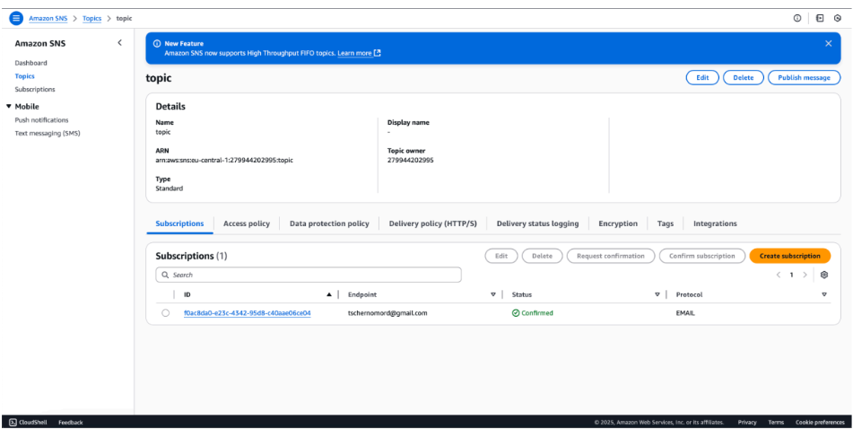
Step 4: System Stress Testing and Operational Validation

Technical Overview
A monitoring system is only as reliable as its ability to trigger under real-world conditions. In this final phase, I performed a Stress Test on the EC2 instance to manually breach the defined thresholds and validate the end-to-end alerting pipeline (from metric collection to SNS notification).

Execution Steps:
- SSH Access: Established a secure terminal session to the EC2 instance.
- Synthetic Load Generation: I utilized the stress utility (or a high-intensity background process) to force CPU utilization above the $80\%$ threshold:
Bash
# Generating 100% load on 2 CPU cores for 5 minutes
stress --cpu 2 --timeout 300
- Observation: Monitored the CloudWatch dashboard as the metric points were aggregated. After the 5-minute evaluation period, the state transitioned from OK to In alarm.

Validation Logic:
The alarm was triggered based on the following condition:
$$\text{Average}(CPUUtilization) > 80\% \text{ for 1 datapoint within 5 minutes}$$
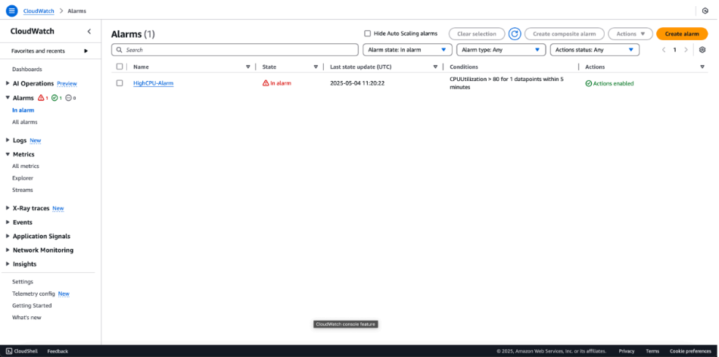
Step 5: Verifying Alert Delivery and Incident Metadata

Technical Overview
The final validation of the monitoring pipeline is the successful delivery of the notification. This step confirms that the Amazon SNS service effectively communicated with the external email endpoint once the CloudWatch Alarm threshold was breached.

Incident Metadata Analysis:
The received notification provides critical data points necessary for an initial security or operational triage:
- Status Change: OK -> ALARM
- Threshold Breach: The email captures the exact value that triggered the alert ($80.93\% > 80.0\%$), providing immediate context without needing to log into the console first.
- Resource Identification: Includes the specific Alarm ARN and Instance ID, allowing an incident responder to quickly identify which asset is under stress.
- Timestamp: Provides a precise UTC record for the event, which is essential for correlation during a forensic investigation or post-mortem analysis.
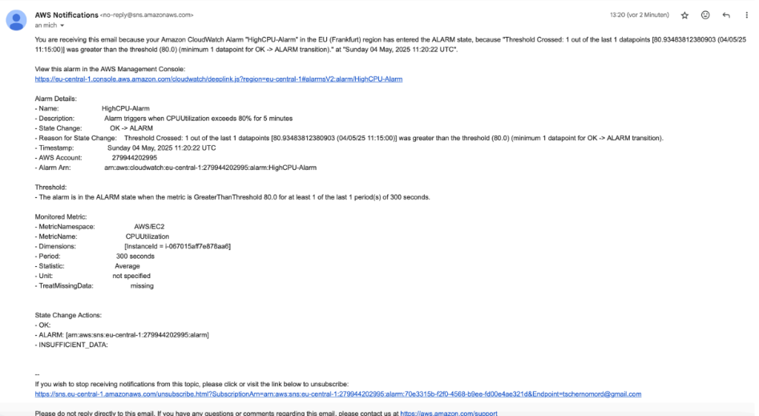
Step 6: Visualizing the Anomaly via CloudWatch Metrics

Technical Overview
Data visualization is a critical component of security monitoring. In this step, I analyzed the CPUUtilization metric graph to observe the physical impact of the stress test on the instance. This visualization confirms the correlation between the manual execution of the stress command and the subsequent breach of the alarm threshold.

Observations:
- Baseline Activity: The graph shows a near-zero baseline before the test, representing the instance in an idle state.
- The Spike: A sharp, vertical ascent in the metric data points indicates the exact moment the synthetic load was applied.
- Threshold Breach: The peak of the graph clearly exceeds the $80\%$ horizontal threshold, providing the visual justification for the alarm state triggered in Step 4.
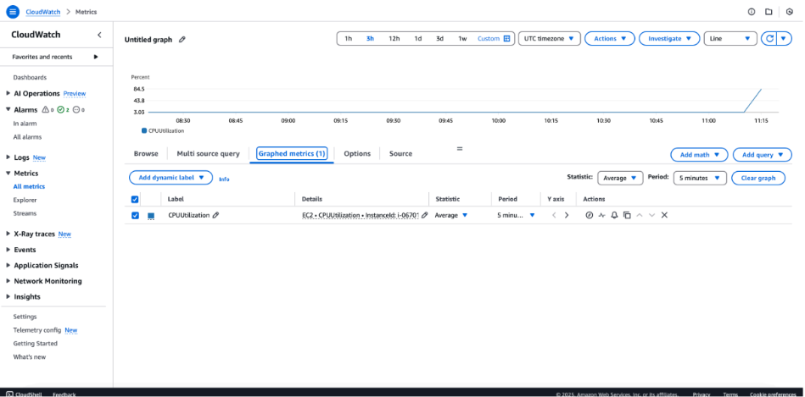
Step 7: Resource Decommissioning and Infrastructure Hygiene

Technical Overview
The lifecycle of cloud infrastructure includes not only deployment and monitoring but also the secure and efficient removal of resources. In this final phase, I performed a systematic cleanup of the laboratory environment to ensure cost-efficiency and prevent "infrastructure sprawl."
[Images showing successful deletion of CloudWatch Alarms and Amazon SNS Topics]

Cleanup Procedures:
- Alarm Decommissioning: Deleted all custom CloudWatch Alarms to stop further metric evaluation and potential noise.
- Notification Pipeline Removal: Deleted the SNS topics and associated subscriptions, ensuring that no stale communication channels remain in the AWS account.
- Verification: Confirmed through the AWS Console that all experimental resources were successfully terminated, leaving the environment in a clean, baseline state.
